SATURD
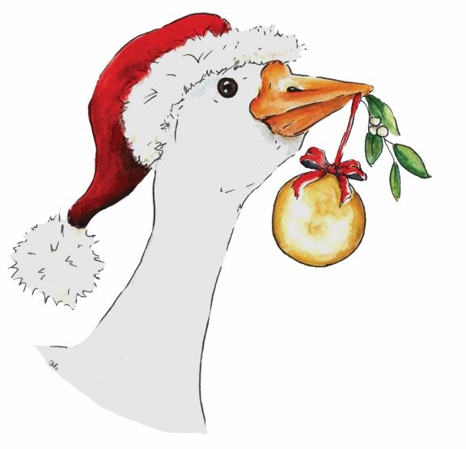
Chertsey Christmas Goose fair – Sat. December 2^{n}
^{d} 2023
Post: c/o 31, Grove Road, Chertsey, Surrey, KT16 9DN
Tel: 07790 604016
email: chertseygoosefair@gmail.com
web: www.chertseygoosefair.com

STALLHOLDERS APPLICATION FORM
NAME:
BUSINESS NAME:

STALLS –
Please specify space required (no extra charge)
ACTIVITY
ON THE DAY
ADDRESS

POST CODE

TELEPHONE
(DAY/EVE)
MOBILE
E-MAIL

STALL CATEGORY  (please tick) | Schools, Scouts, Churches Charities & Charitable fund raisers  (with deposit cheque £15.00) | free
 | Independent small business | £20.00
 | commercial business | £25.00
 | commercial food outlet  (Food stalls must comply with Council hygiene standards) | On request
 | Ice cream van | on request
CHEQUE/BACS PAYMENT.
Cheque payment: Please send cheque for CCGF (Chertsey Christmas Goose Fair) to the address above.
Bacs payment: Please use your ‘business name’ above as reference.
Account name: Chertsey Christmas goose fair Account number:33391280 sort code:20:42:76

FOR INTERNAL USE:

reserves the right to refuse a site to any stallholder who attempts to trade not as stated on the application. Application for stalls can be rejected without explanation.

